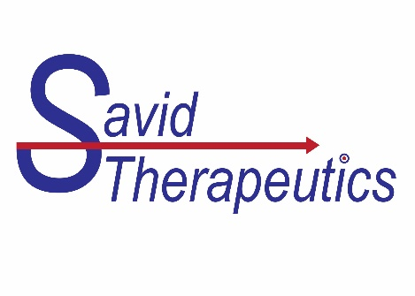
Innovative AMDC Breakthrough: New Hope in Targeted Cancer Treatment
Tokyo, Japan, October 20, 2023 — A game-changing advancement in cancer therapy is on the horizon. Savid Therapeutics and scientists from the University of Tokyo and Tohoku University have unveiled a groundbreaking Antibody-Mimetic Drug Conjugate (AMDC) that can overcome longstanding challenges in cancer treatment.
The AMDC Solution
This research introduces an ingenious solution to the hurdles associated with post-translational modification of proteins, complex manufacturing process and variability in the internalization in cancer cells. The key lies in a method that fuses a monomeric anti-HER2 VHH to “Cupid”, resulting in "anti-HER2 VHH-Cupid." This tetrameric protein can be conveniently purified based on molecular weight, which streamlines production in manufacturing.
A Potent Complex: Duo-HER2 (STI-002)
Anti-HER2 VHH-Cupid non-covalently binds with "Psyche" linked to a potent DNA-alkylating agent, duocarmycin. This complex effectively targets and destroys HER2-expressing human cancer cells in vitro and in vivo, ushering in a new era of cancer treatment.
Promising Cancer Therapy Platform
Savid’s AMDC technology promises to revolutionize cancer therapy by combining targeting precision with potent payloads and streamlined manufacturing. Researchers anticipate significant improvements in patient outcomes and a reduction in traditional treatment side effects.
For media inquiries or more information, please contact:
Michael Chansler, Vice President Business Development, Savid Therapeutics, Inc. mchansler@savidtherapeutics.com

